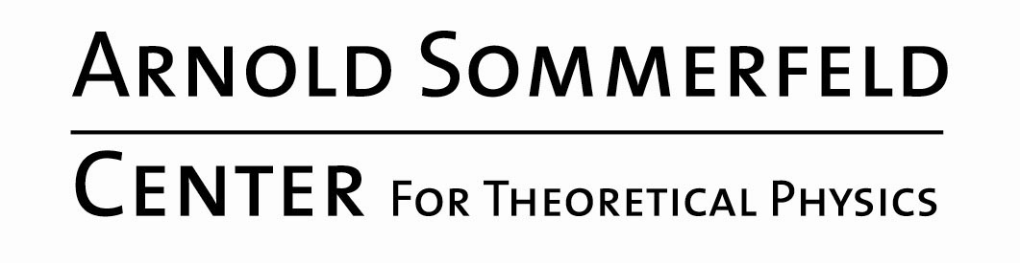 | This Week at the ASC  May 30 – June 5, 2022

NEWS

Tuesday, 31.05.2022

Geometry
16:15 h  Room B252 | J. A. Rodriguez Migueles  LMU  On volumes of complements of periodic orbits of the geodesic flow and filling pairs of multicurves

Wednesday, 01.06.2022
Sommerfeld Theory Colloquium
16:15h  via Zoom | S. Aaronson  University of Texas at Austin  TBA

